BACSIC I2C COMMUNICATION PROTOCAL

STRUCTURE:

* 2 part: Master and slave are connected bay the SDA (data) and SCL (clock) line.
* Slave address
* Standard -100khz, fast mode – 400khz.
* 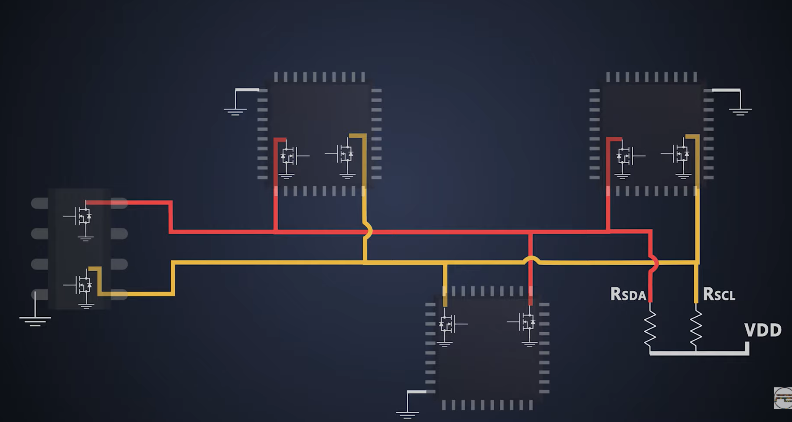
* Pull-up regisoter: Rsda + Rscl.
* When the sda 5v, we can say the SDA line is idle, there has no data.
* 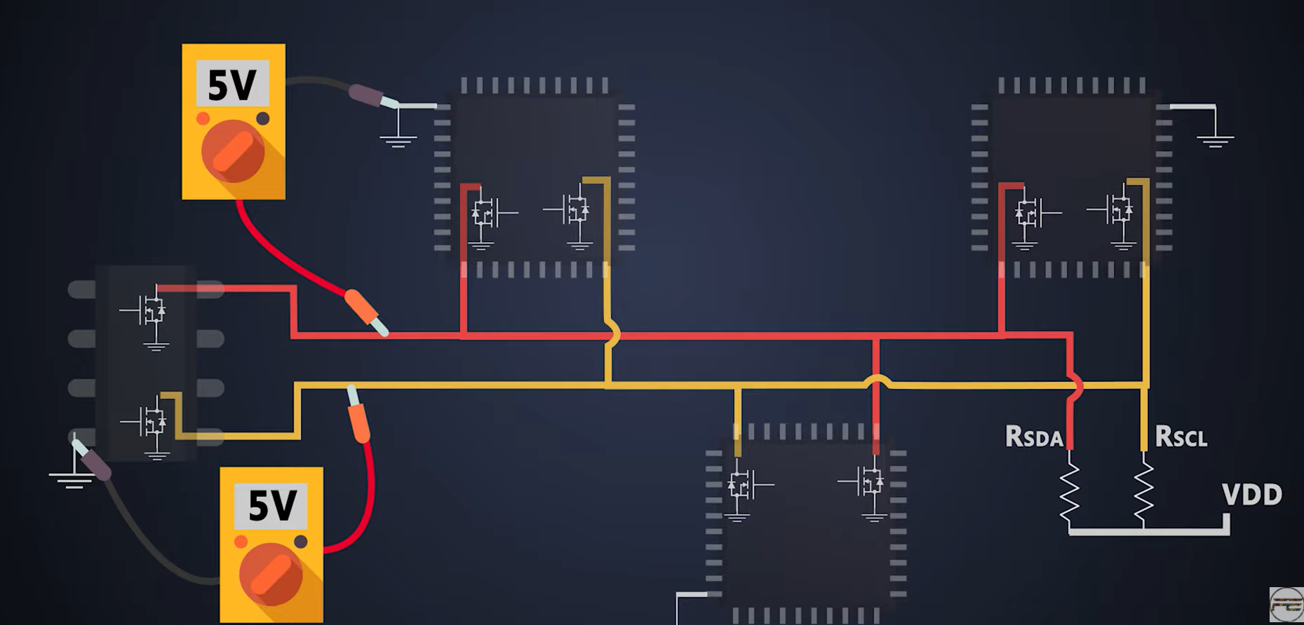
* When the devices want to talk, they pull these SDA line to GND -> the SDA line actived.

THE BIT FRAME:

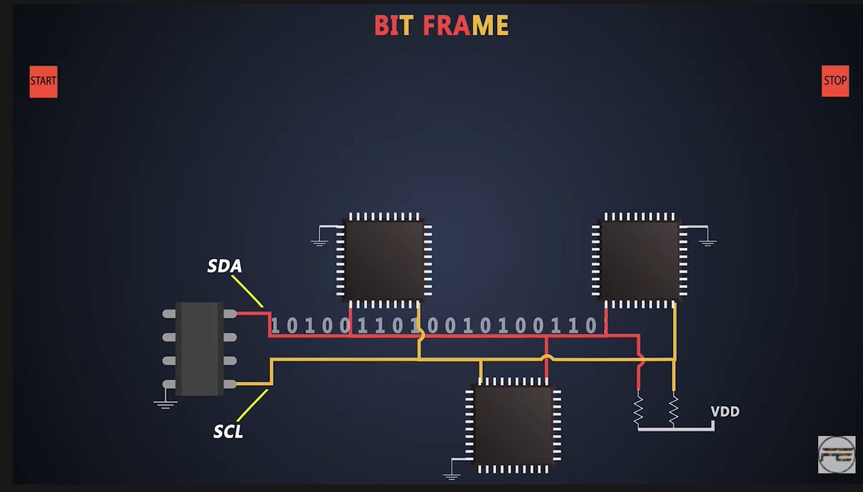

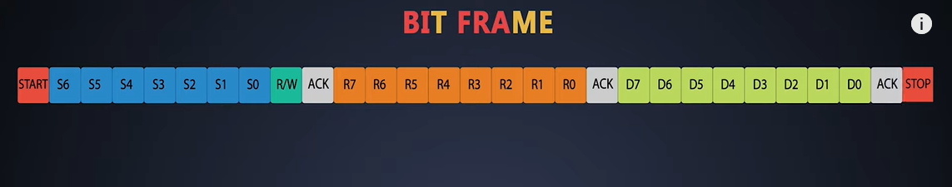

* Firstly, the master send the start bit anh 7 bit (or 11bit) address of the slave it want to connect, then the bit READ/WRITE ( in the code the address <<1|0/1 ( 0 for write, 1 for read).
* Then we heve the bit ACK to accepted.
* The orange bit is the address of the resgiters.
* Final is the 8 bit data and one bit stop.

I2C IN STM32

1) SET UP CUBEMX:

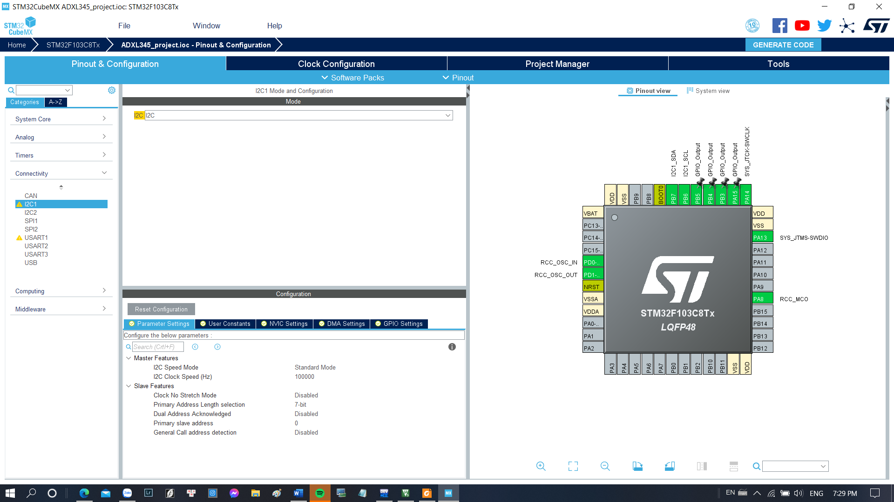

* Standard mode: 100khz
* 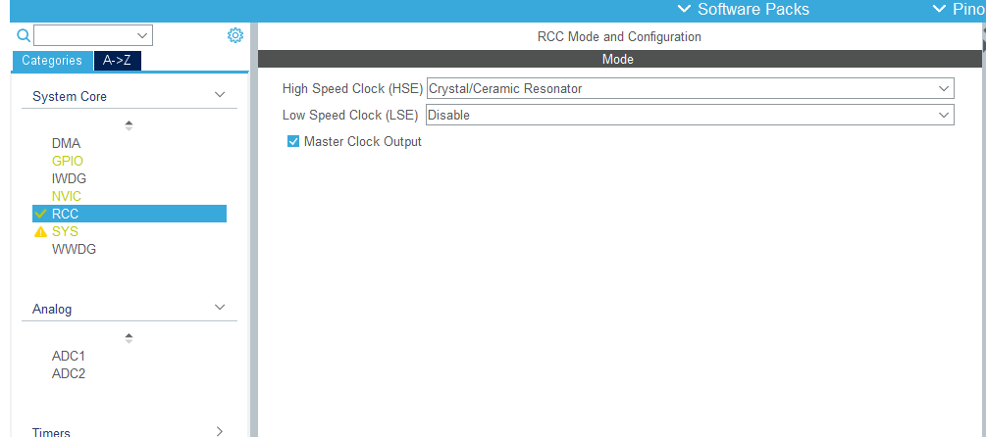

Crystal ‘ clock.

* 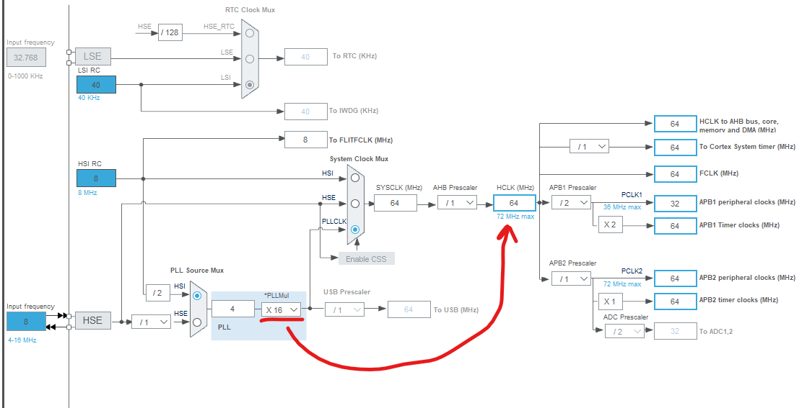
* Set up the clock just enough ( don’t set up too small- with the multiply 1..2..)

-KEILC

- Firstly, we need to read the DEVID of the slave, and this address.

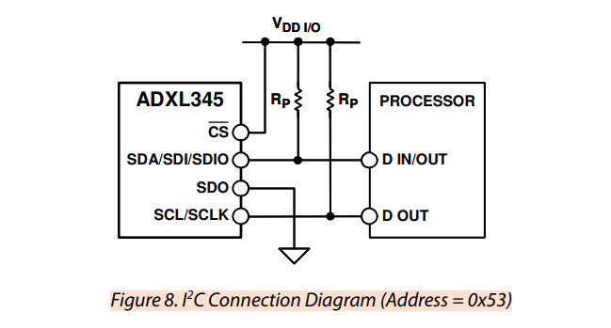

* 0x53 -> (0x53 <<1)| 0/1.
* read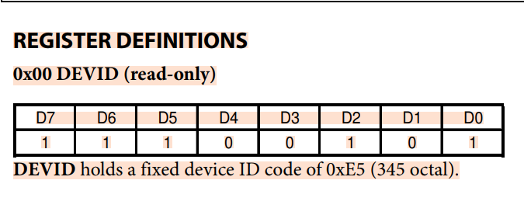
* read the devid in the address 0x00.

SET the POWER CRTL and DATA FORMAT:

-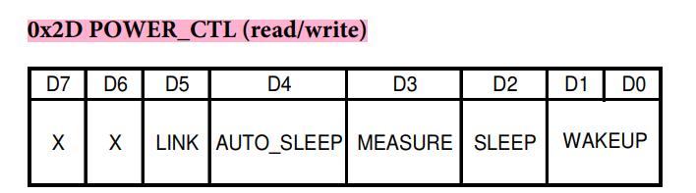

- MODE: MEASURE + WAKE UP 8HZ: 0x08.

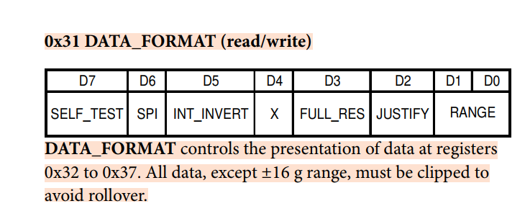

* 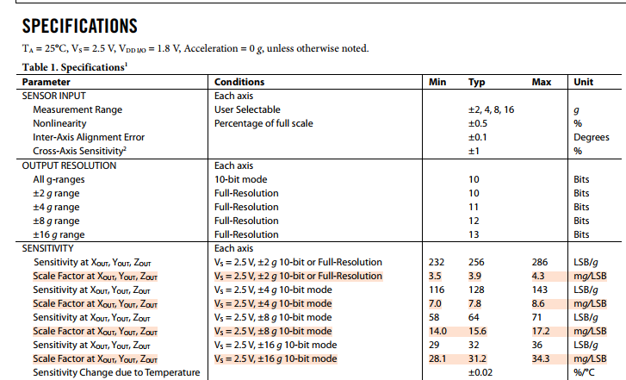
* “THE SCALE FACTOR”
* 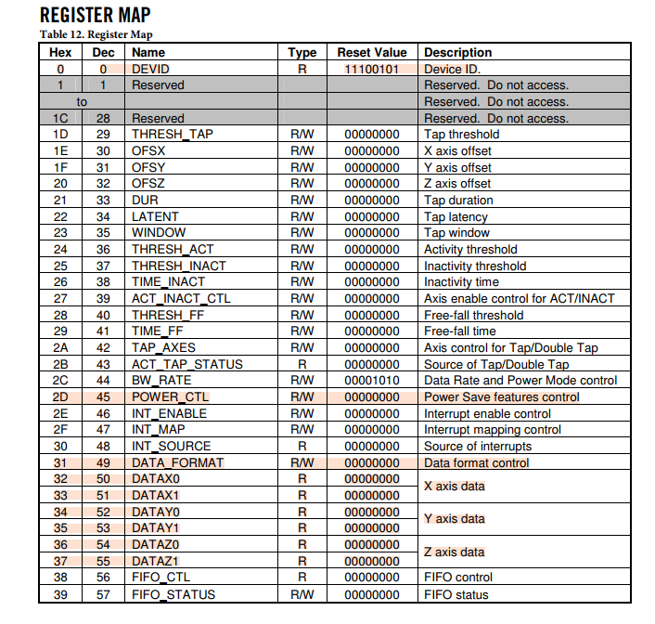
* ADDRESS OF THE DATA: 0x32 > 0x37.

************the code***********

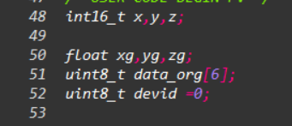

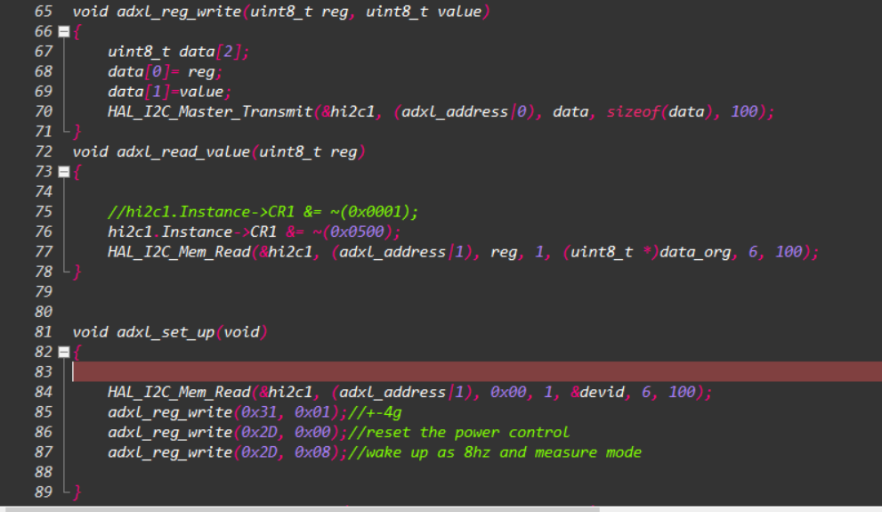

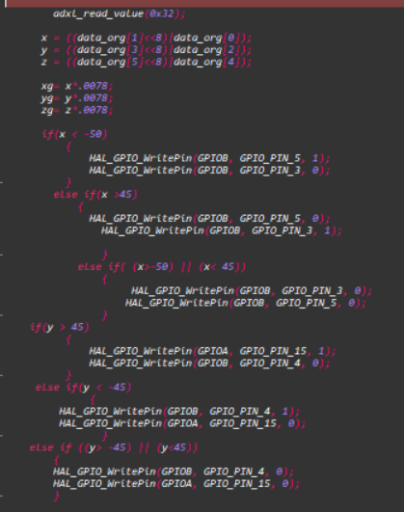

CAUTION: WHEN GET STUCK IN THE BUSY_FLAG, CHECK THE ARATA OF STM32:

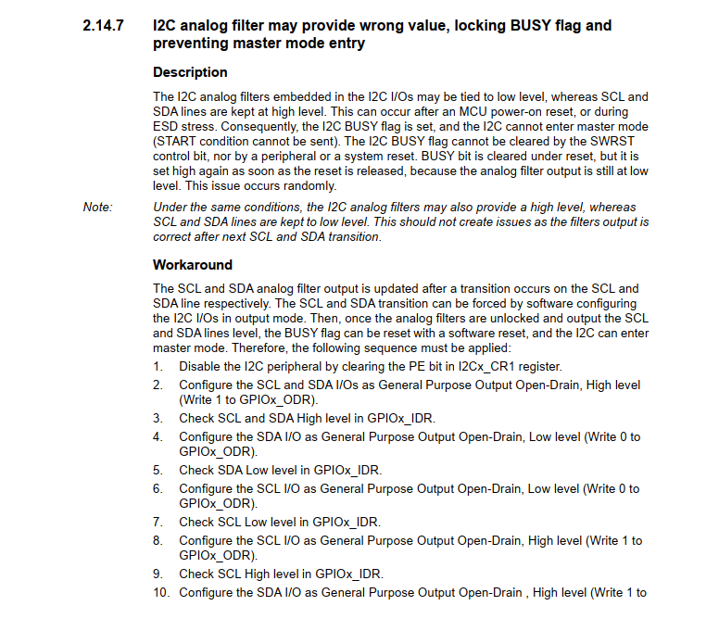

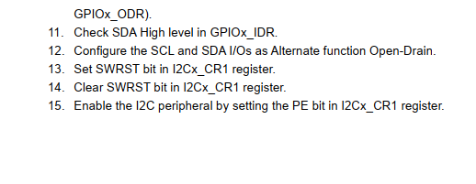

**********thecode********

